**Graphical Enigma Simulator**

**User Guide**

This short guide gives a brief introduction of using the Graphical Enigma Simulator. Video tutorials are also available.

*Requirements*

Windows 7 or later

OpenGL 4 or later

Visual Studio 2010 or later

*Introduction*

The main aim of this simulator is to demonstrate the process of encryption and decryption carried out by the Enigma machine, but only with one rotor. It contains two main features, Encrypt and Decrypt.

Encrypt – allows user to encrypt their plain text into cipher text.

Decrypt – allows user to decrypt their cipher text into plain text.

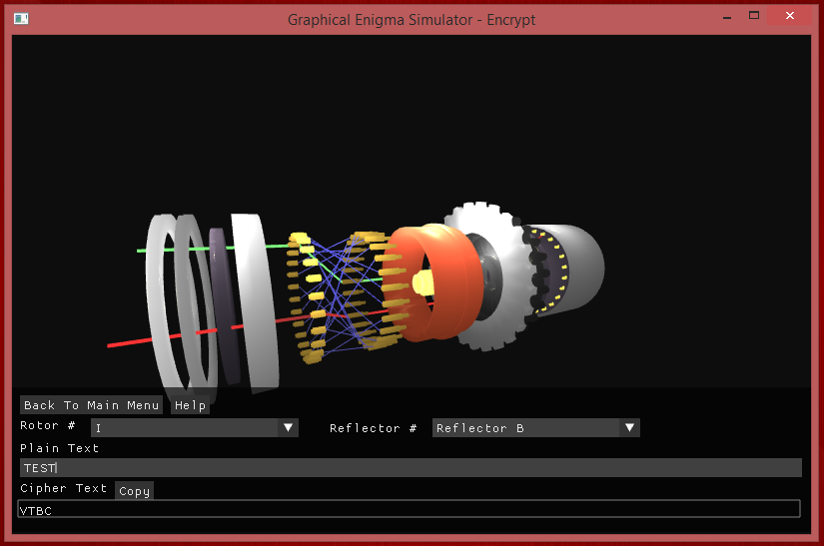

4

2

3

5

1

8

7

6

*Figure 1*

Note: Figure 1 shows the Encrypt mode, but Decrypt mode is very similar.

1 – The simulation which animates upon entering a letter.

2 – Takes the user back to main menu.

3 – Opens up a window which provides help to the user. Describes the simulator and controls.

4 – Allows the user to choose which rotor type. Each rotor has different key.

5 – Allows the user to choose reflector type. Each reflector has different key.

6 – Input field in which user provides text to encrypt. In Decrypt mode, user cannot access this field.

7 – The ciphered text is outputted here. In Decrypt mode, this is an input field which the user provides ciphered text.

8 – This allows the outputted text to be copied. This can then be pasted into the opposing function. For Encrypt mode, text from cipher text box is copied.

For Decrypt mode, text from the plain text box is copied.

The title bar on the window shows which mode you are in: Encrypt or Decrypt. The input provided by the user is automatically capitalised.

*Process explained*

Once a letter is pressed, it is passed to the pins which then maps to the corresponding pins, depending on the rotor setting. Once passed through the pins, it is then passed to the reflector where it will be mapped back to the reflector and passed back to the pins. Once passed back to the pins, the decrypted letter can then be ciphered.

The green current path (the green line) represents the path of the letter you have pressed up until the reflector, where it is then crossed over and the path is returned, shown by the red current path (the red line).

The rotor automatically rotates once you press a letter by one notch, and also reverses upon backspace. Please note that the rotor takes a few seconds to rotate each step, therefore if many letters are entered in a short amount of time, there may be a delay in the rotor completing its rotation.

**For optimal experience it is recommended to take your time!**

**Controls to move rotor:**

Arrow keys:

A - Left key: Move view left (Camera anti-clockwise around y-axis)

B - Right key: Move view right (Camera clockwise around y-axis)

C - Up key: Move view up

D - Down key: Move view down

Numbers:   
E - 1: Rotate rotor clockwise

F - 2: Rotate rotor anti-clockwise

G - 3: Move camera around right

H - 4: Move camera around left

I - 5: Move camera around up

J - 6: Move camera around down

K - 7: Zoom out

L - 8: Zoom in

M - 9: Move left

N - 0: Move right

O - Left Square Bracket ‘[‘: Move up

P - Right Square Bracket ‘]’: Move down

*All these controls move the camera view rather than the actual rotor. Some may have the same effect, but in a different way.*

C, I, O

M

N

L

K

+

_

D, K, P

B, G

A, H

F

E

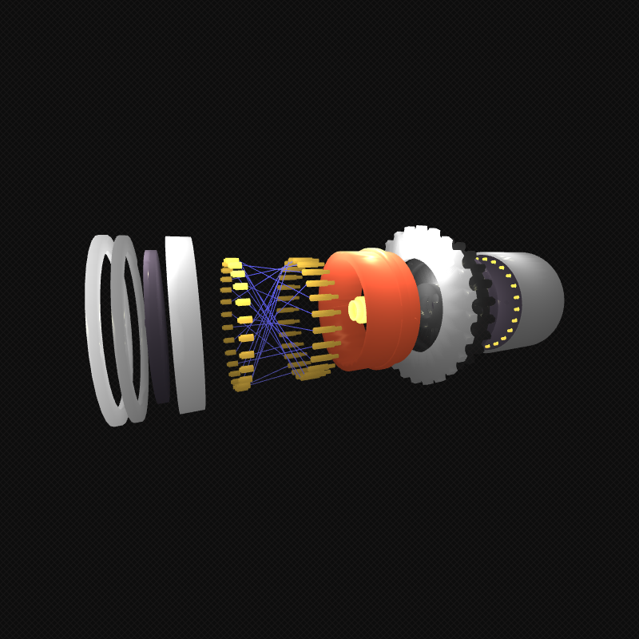

*Figure 2 – Movement details*

The arrows show which way the camera will move around the rotor.

Figure 2 above shows the direction of which the rotor moves – a more detailed explanation of the controls.

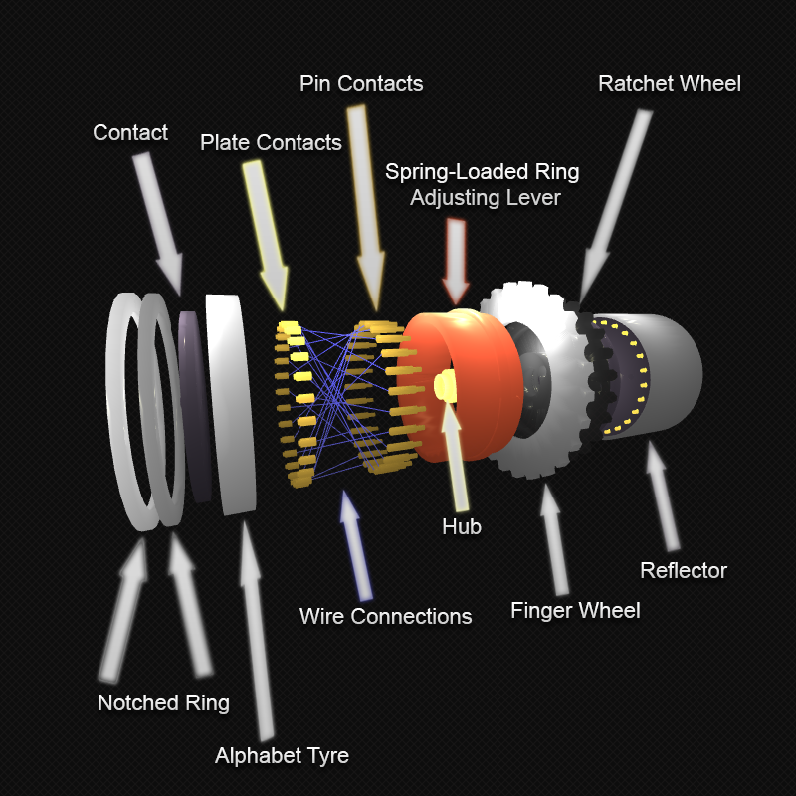

*Figure 3 – Rotor details.*

This above diagram shows the names of the individual components.

**Troubleshooting**

Q. *My ciphered text in one mode is not the same as in the other mode.*

A. This can occur at times if you forget to change the rotor and reflector settings to match that of the previous mode. Alternatively, if this is not the case, then please contact the person who supplied you the simulator.

Q. *I erased a character somewhere in my text but not at the end. Why has the output past this point changed?*

A. This would be because ordering of the letters matter. Therefore, once you erase a character you are changing the ordering. This results in a change of output.

Q. *How can I tell which mode am I in?*

A. On the title bar of the window it states either Main Menu, Encrypt or Decrypt.

Q. *Where can I find information about the components of the rotor?*

A. If you click ‘Help’ in the Encrypt or Decrypt mode, and then click ‘Show rotor details’, an image with the names of the components will be shown.

Q. *The window which displays the information about the components of the rotor won’t move.*

A. This window remains static and cannot be moved. Simply close the window to return to the previous state.

Q. *I’m trying to move the rotor with the mouse but it won’t move.*

A. The mouse does not control the movement of the rotor. The controls can be found earlier on in this document or in the help section of the simulator.

Q. *I’m pressing the spacebar but nothing happens. Why?*

A. The Enigma machines originally did not allow spaces between words. Instead they produced blocks of 4 letters, using ‘X’ as space. However this simulation is designed to just have the text all as one block.

Q. *What is the purpose of the reflector?*

A. The reflector passes the current back. Without it, the encryption method would be weak.

Q. *The lighting and colours look strange.*

A. The simulator requires OpenGL 4 or greater to run. Therefore, on older graphics card it may not run correctly.

Q. *The simulator does not start/it crashes.*

A. Please ensure you are running Microsoft Windows and your graphics card supports OpenGL 4 or greater.

Q. *What operating systems does the simulator support?*

A. Only Windows at the moment.

**Other views of the rotor**

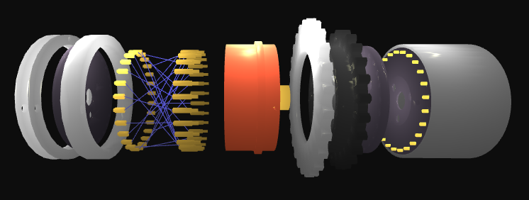

*Figure 4 – Left side*

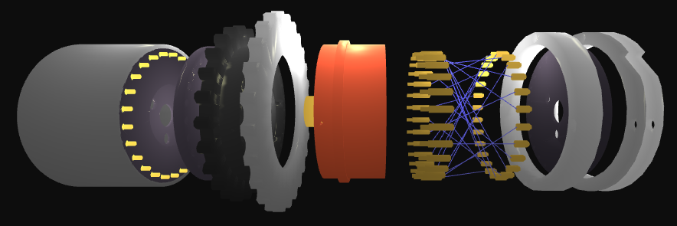

*Figure 5 – Right side*

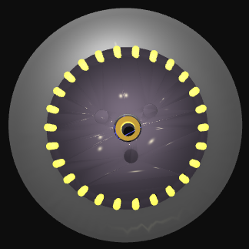

*Figure 6 – Back*

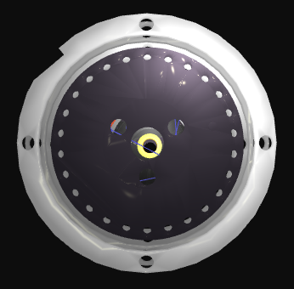

*Figure 7 – Front*